**DREAM HOME REALITY**

1. Introduction

1.1 Overview

"Dream Home Reality" is a phrase that suggests the transformation of one's dream or ideal home into a tangible reality. It generally refers to the process of finding, purchasing, or building a home that matches one's aspirations and requirements. This can involve factors such as location, design, size, budget, and more. Achieving your dream home reality often entails careful planning, financial considerations, and making informed decisions in the real estate market. If you have specific questions or need advice related to your dream home, please provide more details, and I'd be happy to assist further.

1.2 Purpose

1. **Clarity:** Having a clear purpose helps you identify what you want to achieve with your dream home, ensuring that your goals and intentions are well-defined.

2. **Guidance:** It acts as a guiding principle during the planning, design, and construction process, helping you make decisions that align with your purpose.

3. **Alignment:** Your home's purpose ensures that it reflects your values and priorities, making it a space that truly resonates with your lifestyle and needs.

4. **Fulfillment:** Living in a home with a defined purpose can bring a sense of fulfillment, as it serves as a daily reminder of what you set out to achieve.

**2. PROBLEM DEFINITION & DESIGN THINKING**

**2.1 EMPATHY MAP**

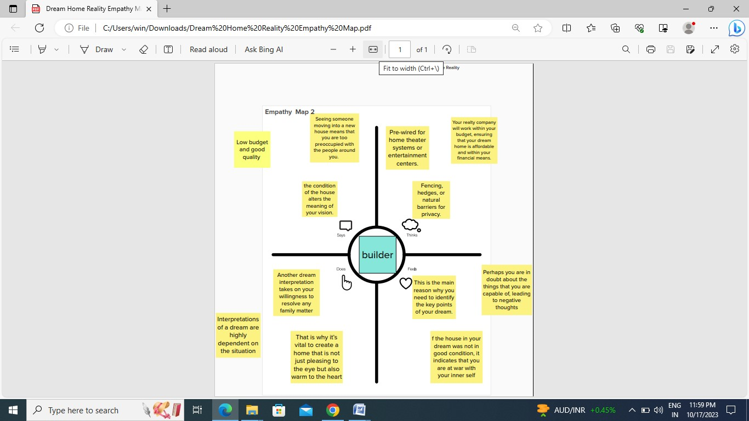

2.2 IDEATION & BRAINSTORMING MAP

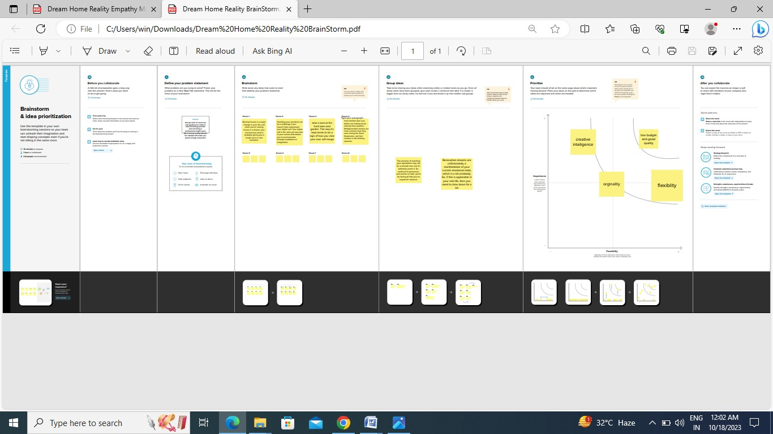

1. **RESULT**

Home is where love, hope, and dreams begin. Given that most people start their own families after moving into their own house, having a new home will be a fresh start for you in more ways than one. It is a sense of accomplishment, satisfaction, and pride.

**4. ADVANTAGES**

1. **Personal Satisfaction:** Achieving your dream home provides a deep sense of personal satisfaction and accomplishment.

2. **Tailored Living Space:** You can design and customize your home to match your unique lifestyle, preferences, and needs.

3. **Comfort and Functionality:** A dream home is often more comfortable and functional, as it's designed with your specific requirements in mind.

4. **Increased Property Value:** A well-planned dream home can potentially increase the value of your property.

5. **Quality of Life:** Living in a space that aligns with your dreams can enhance your overall quality of life and well-being.

**DISADVANTAGES**

1. **Cost Overruns:** Budgeting for a dream home can be tricky, and there's a risk of unexpected costs during construction or renovation.

2. **Time-Consuming:** The process can be time-consuming, from planning to construction, potentially causing delays in moving in.

3. **Stress:** Dealing with the complexities of home construction or renovation can be stressful and may lead to anxiety.

4. **Regulatory Hurdles:** Complying with local building codes, permits, and regulations can be challenging and time-consuming.

5. **Unforeseen Issues:** Unexpected problems, like structural issues or design changes, can arise during the construction process

**5. APPLICATION**

Dream home reality applications are software tools or apps that help individuals in the process of finding and purchasing their ideal or dream home. These applications typically offer various features and functionalities to make the home-buying process more convenient and efficient. Here are some common features and functionalities found in dream home reality applications:

1.property listings

2.photos and virtual tours

3.Map integration

4.Filters and preference

5. Mortgage calculators

6. Contact agents

7. User reviews and ratings

8. Financing information

**6. CONCLUSION**

In conclusion, dream home reality applications have revolutionized the way people search for and purchase their ideal homes. These apps provide a wide range of features and tools that make the home-buying process more convenient, efficient, and informed. From property listings and virtual tours to mortgage calculators and market insights, these applications empower individuals to explore, compare, and evaluate potential homes with ease. They also facilitate direct communication with real estate agents and property owners, streamlining the entire process. As technology continues to advance, dream home reality applications play a vital role in helping people turn their homeownership dreams into reality.

**7. FUTURE SCOPE**

The future scope of dream home reality, or real estate technology, is promising and continues to evolve with advancements in technology and changing consumer preferences. Here are some key areas of future growth and development in this field.

**8. APPENDIX**

**A. Source Code**